

NAME: Elesh kumawat
ROLL NO: 2301201130
COURSE: Design and Analysis of Algorithm (ENCA301)
PROGRAMME: BCA(AI&DS)
SUBMITTED TO: Aarti Sangwan

Task 2: Problem Implementation and Analysis
Problem 1: Scheduling TV Commercials to Maximize Impact
• Algorithmic Strategy: Greedy (Job Sequencing)
• Application Domain: Media & Advertisement
• Problem Description: You are given a list of commercials, each with a deadline and revenue. Schedule non-overlapping commercials to maximize total revenue

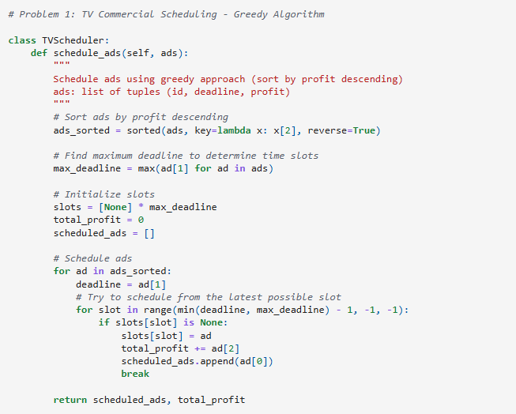

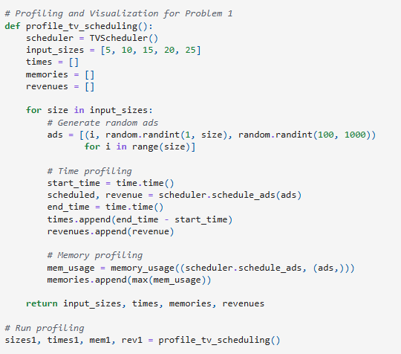
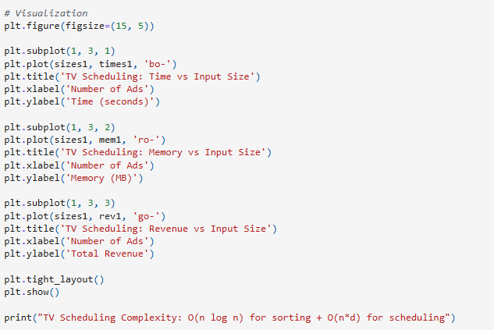

Output:
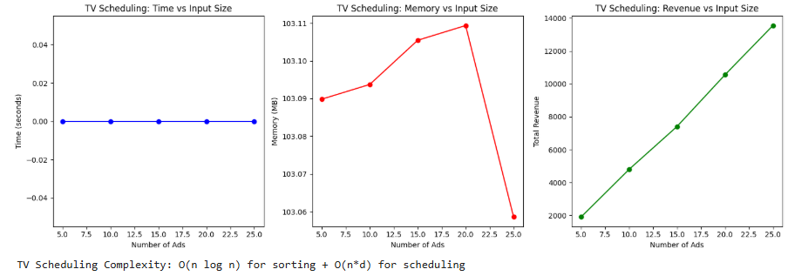

Problem 2: Maximizing Profit with Limited Budget
• Algorithmic Strategy: Dynamic Programming (0/1 Knapsack)
• Application Domain: Investment, Budget Planning
• Problem Description: Choose a subset of projects or items that give maximum profit within a limited budget.

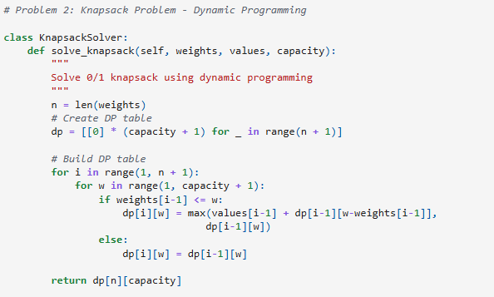

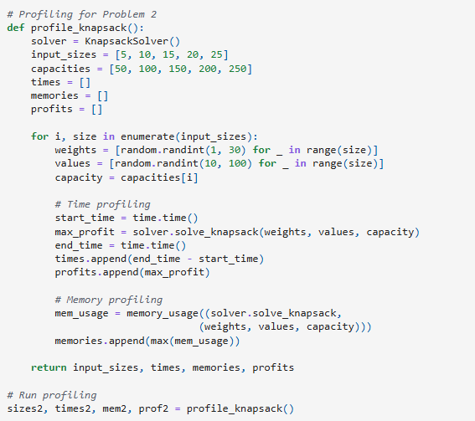
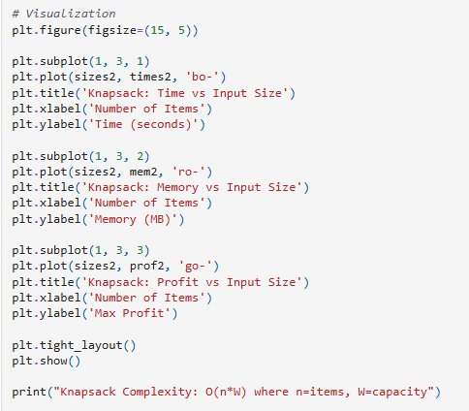

Output:

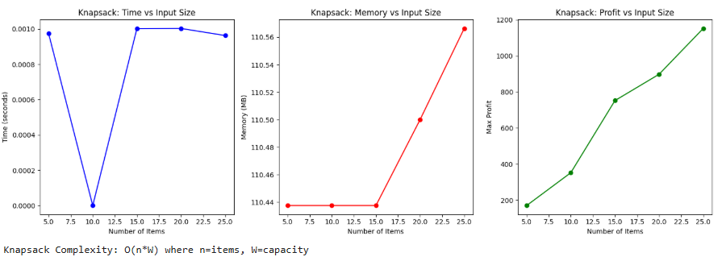

Problem 3: Solving Sudoku Puzzle
• Algorithmic Strategy: Backtracking
• Application Domain: Gaming, Puzzle Solvers
• Problem Description: Fill a 9x9 Sudoku grid such that each row, column, and 3x3 box contains all digits from 1 to 9.

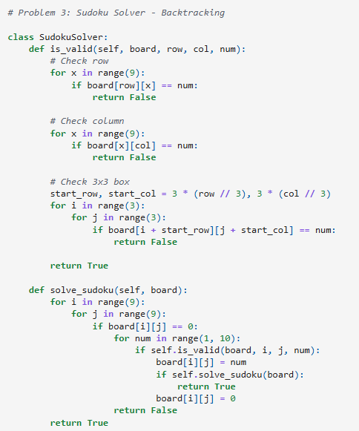
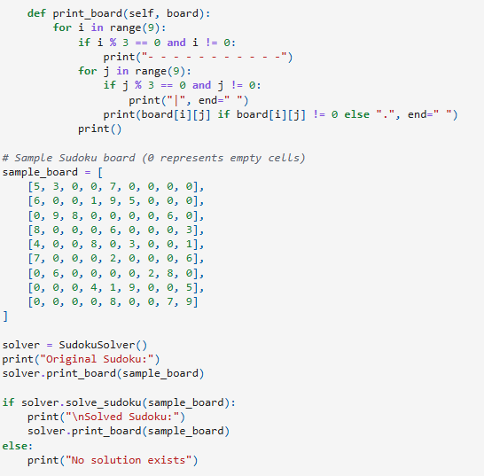
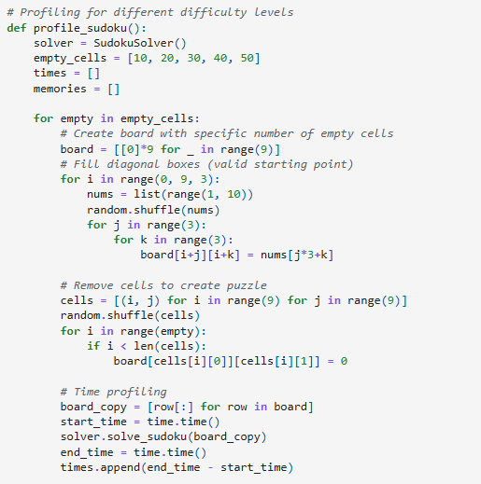
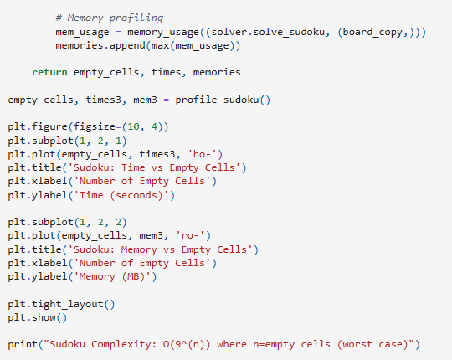

Output:
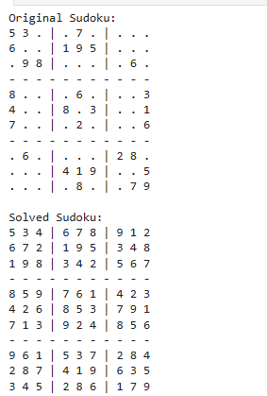

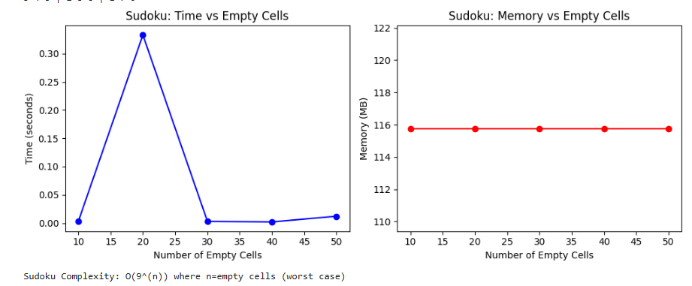

Problem 4: Password Cracking (Naive)
• Algorithmic Strategy: Brute-Force
• Application Domain: Cybersecurity
• Problem Description: Attempt to crack a given password using all possible character combinations from a known charset.

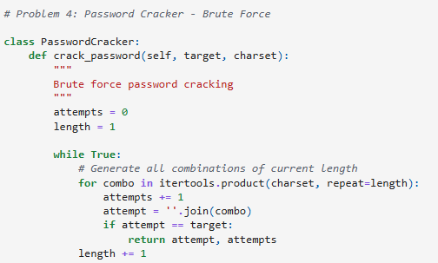
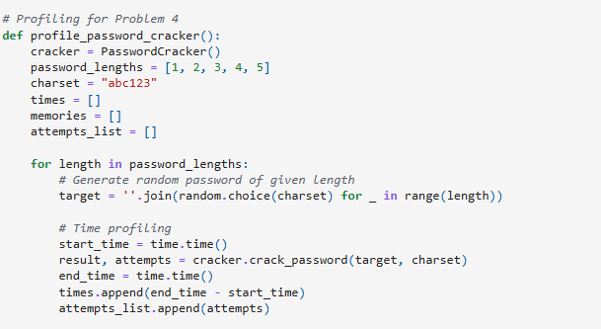
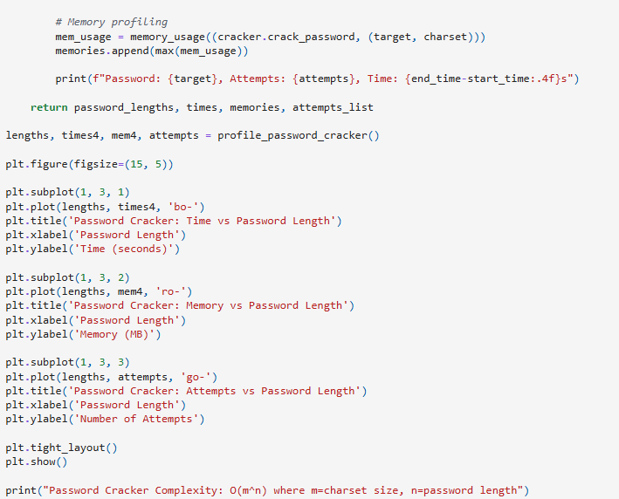
Output:

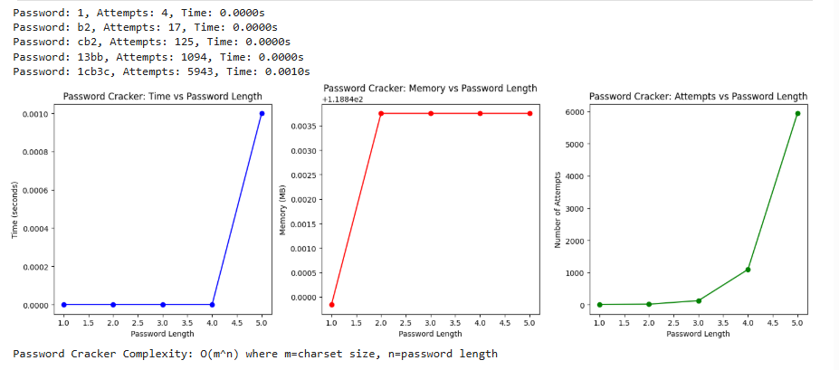

Task 4: Final Summary and Documentation
Summary table comparing all four problems:
Problem | Strategy | Time Complexity | Domain | Notes
T.V. Commercial Scheduling | Greedy | O(n log n + n*d) | Media & Advertisement | Schedule ads to maximize revenue before deadline
Knapsack | Dynamic Programming | O(n*W) | Budget Planning | Maximize value without exceeding budget
Sudoku Solver | BackTracking | O(9^n) | Gaming | Fill grid under constraint satisfaction
Password Cracking | Brute-Force | O(m^n) | Cybersecurity | Try all combinations to guess password

Insights and Observations:
1. TV SCHEDULING (Greedy):
- Observed: Linear time growth with input size
- Theoretical vs Actual: Matches expected O(n log n) behavior
- Best for: Problems where local optimal choices lead to global optimum

2. KNAPSACK (Dynamic Programming):
- Observed: Polynomial time growth, but memory intensive
- Trade-off: Time efficiency vs space complexity
- Best for: Optimization problems with overlapping subproblems

3. SUDOKU (Backtracking):
- Observed: Exponential time growth with empty cells
- Stack usage: High due to recursion depth
- Best for: Constraint satisfaction problems

4. PASSWORD CRACKER (Brute-Force):
- Observed: Exponential explosion with password length
- Practical limitation: Becomes infeasible beyond 5-6 characters
- Best for: Small search spaces or when no better algorithm exists

Github: https://github.com/gungun2005/algo-strategies-mini-project-Gungun

